

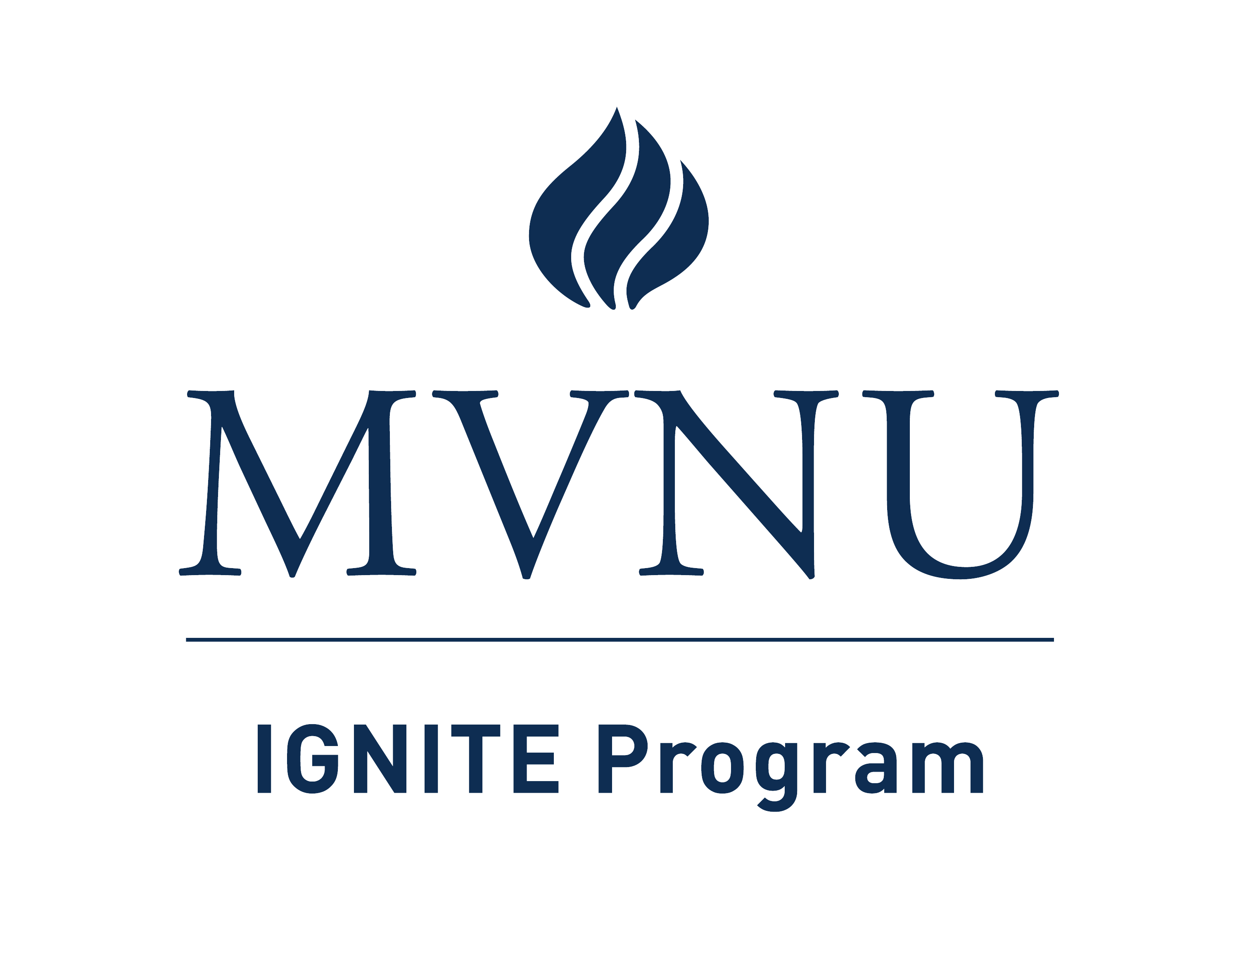

The total cost of the IGNITE Program aligns with the cost of typical college expenses at Mount Vernon Nazarene University and includes the annual cost for all IGNITE core courses and support fees, which are designated to meet students’ needs as well as fees that are in place for all students living on campus including housing, food, and student fees.

**The prices listed on this document are for the 2024-2025 academic year.**

|  |  |  |  |
| --- | --- | --- | --- |
|  |  |  |  |
| **1st Year Cohort 1** | **Fall** | **Spring** | **Total** |
| Independent Living Course | $2,940 | $2,940 | $5,880 |
| Overnight, live-in support fee | $3,142 | $3,142 | $6,284 |
| Independent Living Lab | $1,470 | $1,470 | $2,940 |
| Independent Living Lab Fee | $250 | $250 | $500 |
| Independent Study | $2,940 | $2,940 | $5,880 |
| Independent Study Student Support Fee | $1,000 | $1,000 | $2,000 |
| Employment Course | $2,940 | $2,940 | $5,880 |
| Employment Support Fee | $1,000 | $1,000 | $2,000 |
| Summer Orientation | $1,200 | -------- | $1,200 |
| Internship | --------- | $2,940 | $2,940 |
| Housing | $3,142 | $3,142 | $6,284 |
| Food | $2,055 | $2,055 | $4,110 |
| Student Fee | $237 | $237 | $474 |
| Technology Fee | $265 | $265 | $530 |
| Total IGNITE Program Costs Cohort 1 2024-2025 |  |  | $47,552 |

800 Martinsburg Road  Mount Vernon, OH 43050  mvnu.edu/ignite